Project Report

SecureEdgeAI: Local AI Assistant

Table of Contents
SecureEdgeAI: Local AI Assistant 1
Executive Summary 2
1. Introduction 3
2. Solution Overview 4
3. Data and Methodology 4
4. Data Visualization and Communication 5
5. Market and Differentiation 8
6. Scalability and Recommendations 8
7. Ethics and Forecast 9
Pricing 10

- Why this SecureEdgeAI? Conveys that you give clients a security “edge” by keeping their data on-prem.
- Company Type: A boutique LLC specializing in on-premises AI solutions.
Legal Structure: Limited Liability Company (LLC) for liability protection and pass-through taxation.
Positioning: Hands-on AI consultancy + managed-services partner for small to mid-size businesses.

Executive Summary
Small businesses, students, and independent professionals need AI-driven capabilities, summarization, contract review, personalized outreach, slide-deck outlining. yet cannot risk exposing their sensitive data to cloud services. Existing online AI platforms log prompts and outputs on external servers, creating privacy, compliance, and security concerns that many organizations are unwilling or unable to accept.
This report proposes a turnkey, fully offline LLM Assistant, customized for small-scale operators using open-source tools like Open WebUI, Ollama, and Qwen3. The system runs locally on client-owned hardware, ensuring data sovereignty, fine-tuned workflows, and zero dependency on external APIs.

1. Introduction
Problem Statement
Small businesses increasingly rely on digital tools to streamline operations, communicate with customers, and generate content. However, most lack access to affordable, secure AI solutions tailored to their needs. Cloud-based AI platforms, while powerful, often introduce risks that small operators cannot accept, particularly concerns around data privacy, internet dependence, recurring subscription costs, and a lack of customization for their specific domain. Generic AI models also struggle to understand industry-specific terminology or workflows. Compounding this is the fact that many small businesses do not have the technical expertise required to host, fine-tune, or maintain AI systems themselves. There is a clear need for a secure, easy-to-use, fully offline AI assistant that delivers practical value without compromising data ownership or requiring advanced technical skills.

Issue to Solve
The issue we aim to solve is the lack of accessible, privacy-first AI solutions for small business owners and independent professionals. While AI can dramatically improve productivity, most available tools operate through the cloud and involve data being transmitted to external servers, creating privacy, compliance, and trust issues. Furthermore, current solutions are rarely customizable to specific industry needs, leaving users with generic outputs that do not reflect their unique terminology or workflow. Many small business owners also lack the technical expertise to deploy AI tools themselves. Our solution is designed to remove these barriers by delivering a fully offline, locally hosted, and highly customizable LLM assistant that works securely and efficiently on client-owned hardware.
Target Audience/Stakeholder/Customer
- Small business owners looking for AI-driven automation
- Industry professionals interested in localized AI solutions
- Developers and AI researchers focusing on fine-tuned LLM applications
- Potential customers such as restaurants, marketing agencies, and educational institutions are interested in deploying AI-driven automation
Project Selection
We identified a recurring theme among local entrepreneurs: a desire to leverage AI but hesitation around privacy and complexity. Many expressed concerns over sending proprietary data, such as customer lists, financials, or internal documents, to cloud-based AI tools. At the same time, they lacked the in-house technical expertise needed to deploy or fine-tune large language models on their own. The recent emergence of open-source AI tools like Qwen3, Open WebUI, and Ollama provided an opportunity to deliver a powerful, cost-effective solution that runs entirely offline. Recognizing this gap, we designed Local AI Assistany to make secure AI accessible and practical even for non-technical small business owners.

2. Solution Overview
High-Level Description of the Solution
SECUREEDGE AI CONSULTING is a privacy-first, Our local AI assistant that runs entirely offline. We consult with clients to understand their specific business needs, install a custom AI stack using Open WebUI and Ollama on their machine, deploy the Qwen3 model (in quantized or full form), and build industry-specific prompt templates.

Considerations for the Solution
- Privacy: Ensuring all processing happens locally and no data is shared externally.
- Hardware constraints: Using quantized models (4-bit) for systems with as little as 16 GB RAM.
- Customization: Supporting prompt profiles for legal, educational, creative, or retail workflows.
- Ease of use: Implementing drag-and-drop interfaces, pre-saved prompts, and documentation.
- Scalability: Allowing clients to start with basic tasks and expand their assistant’s capabilities.

3. Data and Methodology
Data Source and Selection
Our solution does not rely on a public dataset. Instead, we fine-tune models using private, client-provided data such as contracts, lesson plans, sales exports, or previous marketing content. This ensures relevance and confidentiality. For demos and onboarding, we use synthetic examples or publicly available datasets that simulate common small-business documents.
Methods/Models Used
- LLMs: LLaMA3, Qwen3-7B for light tasks; LLaMA3-11B or for more complex domains
- Quantization: Use 4-bit quantized models for lower memory usage
- Inference Engine: Ollama, optimized for CPU and lightweight GPU inference
- Interface: Open WebUI, with user access controls and prompt configuration
- Automation: Python scripts for tasks like batch summarization or CSV analytics
Concerns and Solutions
Concern | Mitigation Strategy
Limited technical skills | Starter plan includes full setup, tutorial videos, and support
Hardware incompatibility | Provide upgrade options and run quantized models
Security of cached data | Enforce full-disk encryption and secure storage scripts
Feature creep | Tiered pricing and scoped statements of work

4. Data Visualization and Communication
Visualization Strategy
- Before/after reports to compare task time reduction
- Latency charts for model performance on various hardware
- Clause detection heatmaps in legal applications
- Mock dashboards simulating AI-powered sales or marketing reports
These visuals will be used in client demos, case studies, and promotional content.
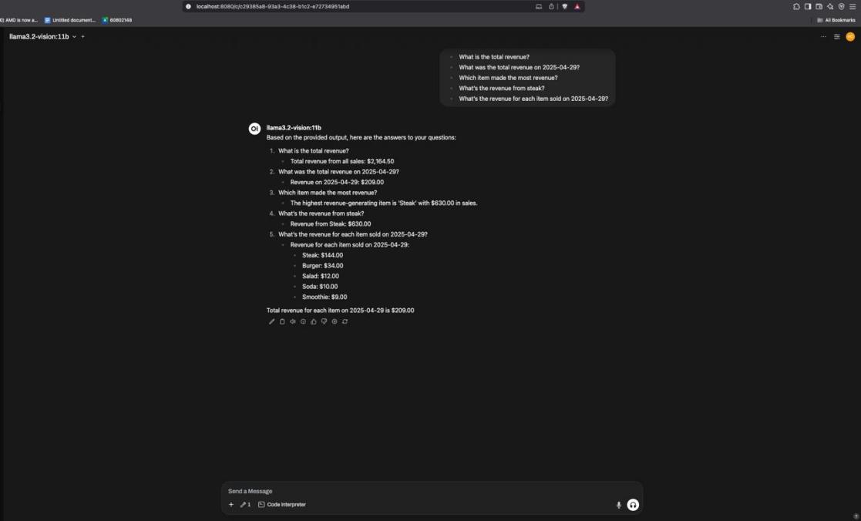
Figure 1: LOCALAIASSISTANT generating revenue analysis from business data using the LLaMA Vision model.

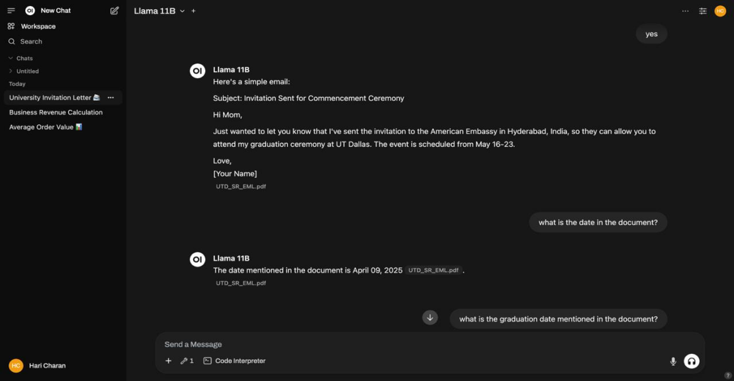

Figure 2: LOCALAIASSISTANT assists with drafting a personalized email based on the extracted document content.

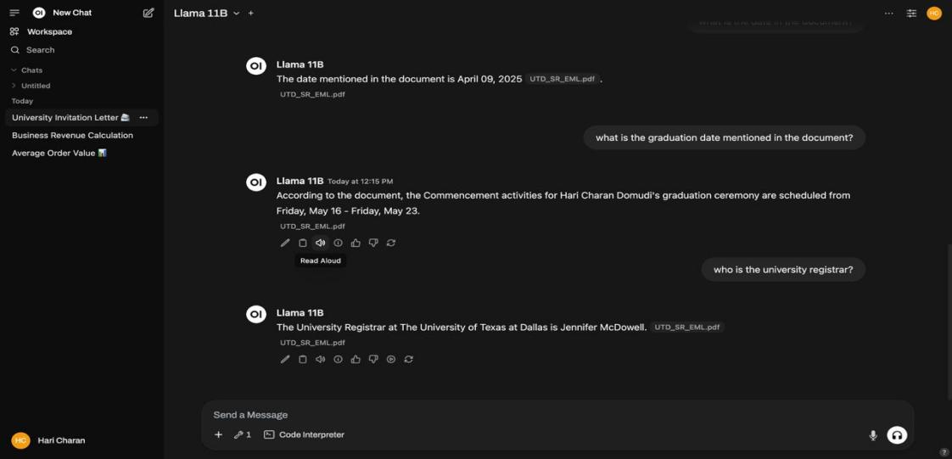
Figure 3: LOCALAIASSISTANT responds to follow-up queries, identifying dates and specific details from the uploaded document
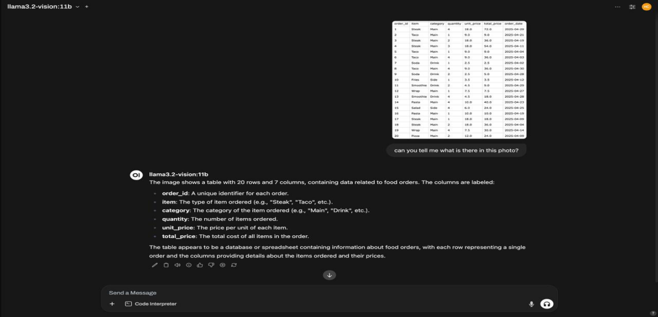
Figure 4: LOCALAIASSISTANT analyzing a food order table image and converting it into structured data.
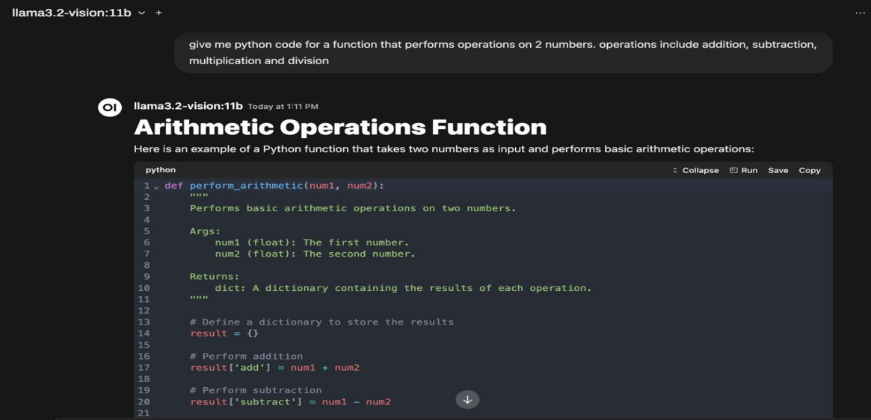
Figure 4: LOCALAIASSISTANT generating a Python script to perform arithmetic operations for educational or automation tasks

5. Market and Differentiation
Market Introduction Plan
- Free pilot sessions for 3–5 local businesses per category
- Partnerships with IT hardware vendors and MSPs
- A LinkedIn/YouTube campaign with demos and customer stories
- Tiered pricing with low-entry costs and pay-as-you-scale upgrades
We will focus initial efforts on sectors where privacy concerns are strongest and AI ROI is most tangible—education, healthcare, legal, and marketing.
Unique Differentiators
- 100% offline, self-contained AI deployment
- Fine-tuned prompt templates per industry
- No subscriptions—one-time setup with optional retainer
- Local integration with existing business data and files
Why You Over Competitors
Our solution is not a generic AI interface it is a locally installed, customizable tool tailored to the client’s use case and hardware. We provide setup, training, and ongoing support, unlike cloud AI tools that offer only generic interfaces and limited security guarantees.

6. Scalability and Recommendations
Challenges to Scaling
- Hiring/training technical staff to replicate installs across clients
- Managing version updates and patching across different hardware
- Educating clients about the benefits of local vs. cloud AI
- Pricing appropriately for different market segments
Implementation Team Advice
- Use pre-built deployment scripts (Docker or Ansible)
- Maintain a GitHub repository for prompt templates and model versions
- Track each client’s configuration in a private CRM
- Offer optional monitoring and support via encrypted remote access

7. Ethics and Forecast
Data Protection Issues
- Issue: Unencrypted swap or temporary files
  - Mitigation: Set up full-disk encryption and secure cache directories
- Issue: UI exposed to LAN
  - Mitigation: Configure WebUI to bind only to localhost and firewall all external access
- Issue: Data backups
  - Mitigation: Provide encrypted backup automation scripts and guidance
These will be bundled into a “Security Add-on Kit” available in higher-tier plans.
Here’s the same three-year forecast expressed in narrative form:
Year 1 (2025):
You’ll begin by rolling out both plans through pilot engagements and word-of-mouth. You can reasonably expect to sign up around 20 Starter Plan clients (20 × $499 = $9,980) and 5 Growth Plan clients (5 × $999 = $4,995). That brings your Year 1 revenue from these two offerings to about $14,975.
Year 2 (2026):
With referral partnerships, targeted LinkedIn/YouTube campaigns, and stronger sales momentum, you could grow to roughly 50 Starter Plan customers (50 × $499 = $24,950) and 20 Growth Plan customers (20 × $999 = $19,980), for a combined total of $44,930.
Year 3 (2027):
As your deployment scripts, template library, and support processes mature, capacity expands to serve up to 100 Starter Plan clients (100 × $499 = $49,900) and 40 Growth Plan clients (40 × $999 = $39,960), yielding $89,860 in revenue.
Underlying Assumptions:
- Go-to-Market Traction: Early pilots convert at ~5–10%, with higher Growth-plan uptake once clients see ROI.
- Scalable Operations: Automated on-boarding and deployment allow supporting 100+ Starter engagements without linear headcount growth.
- Upsell Potential: A meaningful portion of Starter clients will migrate to Growth as their needs for analytics and LoRA fine-tuning increase.
This trajectory brings you from roughly $15 K in Year 1 to nearly $90 K by Year 3 on these two core offerings alone.
We anticipate steady growth as cloud privacy concerns rise and local AI tooling becomes more standardized.

Pricing
Plan Name | Plan Price (USD) | Included Services / Deliverables | Recommended Hardware Specification | Approx. Hardware Cost (USD) | Model Details
Starter Plan | $499 | • 2-3model deployment  • 10 prompt template  • CSV-based demo | GEEKOM A8: Ryzen 7 CPU, 32 GB RAM, 1 TB SSD | $500 | Llama3-14B, 8-bit quantized  Qwen3-32B, 4-bit quantized
Growth Plan | $999 | • 3 industry-specific prompt templates  • Analytics dashboard  • LoRA fine tuning | Mac mini: 64 GB RAM | ≈$1,800 | Llama3-70B, 4-bit quantized  Qwen3-32B, 8-bit quantized + higher context
This version expands technical details, client focus, and operational insights while keeping it accessible to business and technical audiences alike.

